Case Report
DOI: http://dx.doi.org/10.18203/2349-2902.isj20203810
Transoral endoscopic excision of cystic hygroma vestibular approach in adult (novel approach): a case report
Raj N. Gajbhiye, Ganesh K. Kharkate*, Vidhey S. Tirpude
Department of Surgery, GMC Nagpur, Maharashtra, India

Received: 17 June 2020
Accepted: 28 July 2020

*Correspondence:
Dr. Ganesh K. Kharkate,
E-mail: drganeshkharkate@gmail.com

Copyright: © the author(s), publisher and licensee Medip Academy. This is an open-access article distributed under the terms of the Creative Commons Attribution Non-Commercial License, which permits unrestricted non-commercial use, distribution, and reproduction in any medium, provided the original work is properly cited.

ABSTRACT
Lymphangioma, soft tissue tumor was originally reported by R. Backer in 1828 and “cystic hygroma” name was first given by Wernker in 1834. It can occur in the head, neck, axilla, cervico-facial regions and below tongue. Although it is well recognized in children, it may present in adulthood. Cystic hygroma neck is traditionally removed via an overlying incision near or over the swelling. The resultant scar can be displeasing to an adult. Various endoscopic approach present in literature for excision are via neck, anterior chest, combined or robotic assisted. We here, are reporting transoral endoscope excision of cystic hygroma via vestibular approach. A 51 year old female with swelling over anterior aspect of neck, trans-illumination positive, diagnosis confirmed on CT neck, of size ~4×4 cm was our case. We decided for transoral endoscopic vestibular approach for excision, first of its kind with no assisted approach. Patient discharged after 3 post-operative days (PODs). There was mild seroma which resolved within a week. Transoral endoscopic excision of cystic hygroma via vestibular approach without any assisted approach can be applied in adult. Various approach present in literature for excision of cystic hygroma are via neck, anterior chest or combined or robotic assisted. Hence this approach can be an excellent choice for adult cystic hygroma patients who desire to avoid a neck incision. Transoral endoscopic excision of cystic hygroma via vestibular approach was successfully performed. Patient was satisfied with good cosmosis. It results in good cosmesis and better dissection. Hence can be a new method of excision of cystic hygroma in adult.
Keywords: Endoscopic cystic hygroma, Cystic hygroma, Vestibular approach

INTRODUCTION
Cystic hygromas is generally known as a disease of childhood when there is active lymphatic growth. A cystic hygroma can be present as a birth defect (congenital) or develop at any time during a person's life.¹ Presentation in adulthood is rare, and the cause is uncertain, although trauma and upper respiratory tract infection have both been suggested as possible triggers for the onset.² Surgery is treatment of choice of cystic hygroma. Sclerotherapy may be indicated as an alternative to surgery in localized and diffuse macrocystic forms.³ Treatment options for cystic hygroma may be surgical or nonsurgical. The standard transcervical surgical treatment of cystic hygroma may often leave a permanent scar in the neck region in children.⁴ Endoscope-assisted excision of the macrocystic lymphangioma via anterior chest approach in children can be applied effectively, safely and feasibly, allowing adequate exposure for dissection, and resulting in a good cosmetic result, and it would be considered as a new surgical approach for these patients.⁵ Diagnosis in adults is considered to present a greater challenge than in children, and final diagnosis is usually based on postoperative histology.² In our case, clinical as well as CT findings confirmed the diagnosis.
Cystic hygroma neck is traditionally removed via an overlying incision near or over the swelling. The resultant scar can be displeasing to an adult patient. Various endoscopic approach present in literature for excision are via neck, anterior chest or combined or robotic assisted. Transoral endoscopic thyroidectomy vestibular approach (TOETVA) with the potential for scar-free surgery is a safe, effective procedure which provides good cosmetic outcomes in neck surgery.⁶ TOETVA was shown to be safe and feasible with a reasonable surgical duration and minimal pain scores. This approach shows promise for those patients who are motivated to avoid a neck scar.⁷ However this transoral vestibular approach was never used for excision of cystic hygroma. We are reporting a case of cystic hygroma in adult for transoral endoscopic vestibular approach for excision, first of its kind with no assisted approach.
Case Report
A 51 year old female with swelling over anterior aspect of neck, trans-illumination positive, diagnosis confirmed on CT neck of size ~4×4 cm was our case (Figure 1). X-ray neck showed tracheal deviation towards right (Figure 2).We are reporting a case of cystic hygroma in adult for transoral endoscopic vestibular approach for excision, first of its kind with no assisted approach. Patient was willing for excision and demanded good cosmetic outcome and we decided to proceed with transoral approach. The patient was discharged after three days of postoperative care without any complication, there was mild seroma which resolved completely within 15 days.
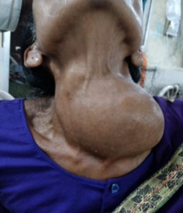
Figure 1: Clinical photograph.
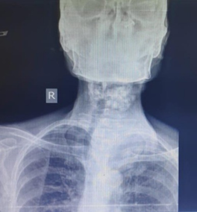
Figure 2: X-ray shows tracheal deviation.
Operative procedure
General anesthesia with nasotracheal intubation extension. Preoperative IV antibiotic give 30 min prior to the procedure.
Oral cavity cleaned with normal saline and povidone iodine before incision.
Operation theatre setup
Surgeon stands on head end of patient with camera assistant. Monitor is placed opposite to the second surgeon on either side of neck of patient (Figure 3).
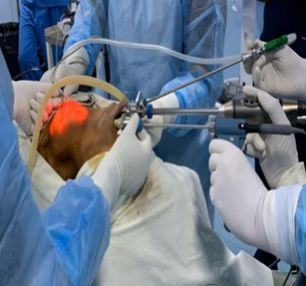
Figure 3: Port position.
In oral vestibular area, incision given over the inferior labial frenulum .A needle is inserted in the subplastimal plane. Mixture of 500 ml normal saline and 5 mL adrenaline is infiltrated in the subplastimal plane above the inferior labial frenulum (in front of lower central incisior) for the first trocar. 10 mm trocar inserted at the middle line (Figure 4). Insufflation maintained at 5-6 mmHg. Then, two lateral 5 mm trocars are inserted in front of the lower canine tooth on either side after the administration of the mixture of normal saline (NS) and adrenaline.
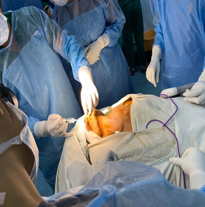
Figure 4: Suplatismal neck inflitration (NS and adrenaline).
Ligasure (energy source) is used for dissection in plane between strap muscle and platysma. Opening the deep fascia between strap muscles in the midline, cystic swelling identified. Dissection begins to separate cystic hygroma from surrounding tissue. A needle inserted via neck skin into the cystic hygroma and fluid aspirated to reduce its size (Figure 5). As a cyst reduced in size, dissection become easier. After complete separating the cyst from surrounding structure, the specimen is put into an endobag and taken out through the 10 mm incision in the oral cavity and send for histopathology (Figure 6). Port were closed using 4-0 absorbable suture. A compression dressing was applied neck for one day. Mouth-wash advised to patient for one week. Patient started oral diet after first postoperative day. IV antibiotic given for 3 days. Tab chymoral forte given for 5 days thrice a day. Patient was discharged on postoperative day 3. Histopathological report suggested cystic hygroma. No clinical evidence of recurrence of swelling noted yet.
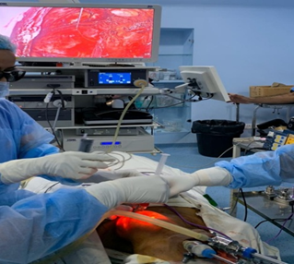
Figure 5: Aspiration of cyst for HPE.
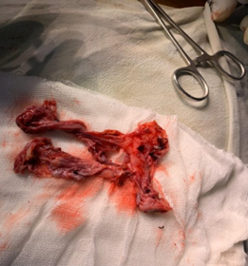
Figure: Specimen.
Discussion
Cystic hygroma is a rare benign abnormality of the lymphatic system generally occurring in young children less than 2 years old.⁴ It is considered as an uncommon differential diagnosis of a progressively enlarging neck mass in adulthood.⁸ The standard transcervical surgical treatment of cystic hygroma may often leave a permanent scar in the neck region .A case report described that the most common adult presentation as asymptomatic painless swelling with trauma and upper respiratory tract infection as possible precipitating factors for onset of cystic hygroma.² In our case, the patient had asymptomatic painless swelling with no identifiable cause.
One case report described that massive enlargement of hygroma very rarely compresses major structures of neck such as larynx, trachea, oesophagus, branchial plexus and great vessels and give rise to clinical symptoms.⁹ In our case, it was a large swelling causing mass effect with tracheal deviation.
Many treatment alternatives exist for lymphangiomas, including surgical excision, laser surgery, cryotherapy, electrocautery, steroid administration, sclerotherapy, embolization and radiation therapy, but surgical excision is the most preferred option.¹ Complete surgical excision has traditionally been considered the treatment of choice for cystic hygroma.¹⁰ Endoscope-assisted excision of the cystic hygroma via different approaches (anterior chest approach alone upper incision alone, combined approach) can be applied effectively, safely and feasibly, allowing adequate exposure for dissection, and resulting in a good cosmetic results, and would be considered as a newly surgery for these patients.⁵ Successful robot-assisted excision of cystic hygroma through a concealed and minimally invasive retroauricular hairline incision in a child less than 2 years of age.⁴
Various approach present in literature for excision of cystic hygroma are via neck, anterior chest or combined or robotic assisted. Here we are reporting a case of cystic hygroma in adult for transoral endoscopic vestibular approach for excision, first of its kind with no assisted approach. After TOETVA, transoral endoscopic excision of cystic hygroma via vestibular approach without any assisted approach can be applied in adult patient. Patient was discharged on postoperative day 3 without any complication, there was mild seroma which resolved completely within 15 days. The patient felt satisfied with the surgery outcomes, especially the cosmetic result.
Conclusion
Transoral endoscopic excision of cystic hygroma via vestibular approach was successfully performed and there was no conversion or any postoperative complications. Patient was very happy and satisfied with good cosmesis. Transoral endoscopic excision of cystic hygroma via vestibular approach without any assisted approach can be applied safely and feasibly, resulting in a good cosmetic result and better dissection and hence could be considered as a new method of excision of cystic hygroma in adults. Hence this approach can be an excellent choice for adult cystic hygroma patients who desire to avoid a neck incision.
Funding: No funding sources
Conflict of interest: None declared
Ethical approval: Not required
References
- Fidan V, Sutbeyaz Y. Lingual cystic lymphangioma in an elderly patient. Yaşlı bir hastada lingual kistik lenfanjiyom. 2008;18(4):260-2.
- Gowa L, Rampat R, Khanb A, Mihaimeed F. Adult-onset cystic hygroma: a case report and review of management. Gd Rounds. 2011;11:5-11.
- Zainine R, El Aoud C, Sellami M, Beltaief N, Sahtout S, Besbes G. Cystic hygroma: report of 25 cases. Tunis Med. 2012;90(1):19-24.
- Lin FCF, Yang TL, Tung MC, Tsai SCS. Robot-assisted excision of cervical cystic hygroma through a retroauricular hairline approach: a case report. J Med Case Rep. 2016;10(1):154.
- Han P, Huang X, Cai Q, Sun W, Liang F, Guo M, et al. Endoscope-assisted excision of macrocystic lymphangioma in neck via anterior chest approach in infants and children. Int J Pediatr Otorhinolaryngol. 2011;75(10):1275-9.
- Le Q V, Ngo DQ, Ngo QX. Transoral endoscopic thyroidectomy vestibular approach (TOETVA): a case report as new technique in thyroid surgery in Vietnam. Int J Surg Case Rep. 2018;50:60-3.
- Anuwong A, Sasanakietkul T, Jitpratoom P, Ketwong K, Kim HY, Dionigi G, et al. Transoral endoscopic thyroidectomy vestibular approach (TOETVA): indications, techniques and results. Surg Endosc. 2018;32(1):456-65.
- Saxena P, Chandra D. Cystic hygroma of neck in an adult female : case report and literature review. 2009;22(2):2-5.
- Derin S, Sahan M, Dere Y, Cullu N, Sahan L. Cervical cystic hygroma in an adult. Case Rep Pathol. 2014.
- Morley SE, Ramesar KC, Macleod DA. Cystic hygroma in an adult: a case report. J R Coll Surg Edinb. 1999;44(1):57-8.

Cite this article as: Gajbhiye RN, Kharkate GN, Tirpude VS. Transoral endoscopic excision of cystic hygroma vestibular approach in adult (novel approach): a case report. Int Surg J 2020;7(9):3136-9.

