**Case Report**

DOI: https://dx.doi.org/10.18203/2349-2902.isj20251196

Pelvic ectopic kidney with malrotation: a rare case report of renal cell carcinoma

Praneeth Aregala*, Sreehari Gowda, Sachin Marda, T. M. Jyoshna

Department of Surgical Oncology, Yashoda Super Specialty Hospitals, Somajiguda, Hyderabad, Telangana, India

**Received:**23 February 2025

**Revised:** 17 March 2025

**Accepted:** 21 March 2025

**\*Correspondence:**

Dr. Praneeth Aregala,

E-mail: pranethraju.a@gmail.com

**Copyright:** © the author(s), publisher and licensee Medip Academy. This is an open-access article distributed under the terms of the Creative Commons Attribution Non-Commercial License, which permits unrestricted non-commercial use, distribution, and reproduction in any medium, provided the original work is properly cited.

**ABSTRACT**

The incidence of renal cell carcinoma in a pelvic kidney is rare and has only been reported in a very small number of cases. We report a 42 years old female patient presented with haematuria. CT scan showed large heterogeneous soft tissue mass arising from a right interpolar region of pelvic kidney with saccular aneurysm and peripheral hpoenhancing lesion. Histopathology after radical nephroureterectomy showed grade II clear-cell renal carcinoma. Renal cell carcinoma of ectopic kidney is a rare disease. Even though the presentation might be atypical and challenging, the treatment strategy is still the same as for tumours of orthotopic kidneys.

**Keywords:** Clear cell carcinoma, Ectopic kidney, Malrotation, Pelvic kidney, Renal cell carcinoma, RCC

INTRODUCTION

Renal malignancy in ectopic pelvic kidneys is an exceptionally rare occurrence, with only twelve documented cases in the literature. Ectopic kidneys can be found in various locations, including pelvic, iliac, abdominal, thoracic, contralateral or crossed; however, the pelvic kidney is the most common site of renal ectopia. These ectopic kidneys are typically more prevalent on the left side and are often asymptomatic, being discovered incidentally during imaging for unrelated issues.1

The incidence of renal cell carcinoma (RCC) in ectopic kidneys is notably low. Although RCC constitutes about 80% of renal malignancies, its occurrence in ectopic kidneys is uncommon.2 Ectopic kidneys, located outside their normal position, are usually asymptomatic but can cause problems like hydronephrosis or kidney stones due to abnormal urine drainage. These kidneys are often dysplastic and non-functional.3 Symptoms, if present, may include vague abdominal pain, ureteric colic, hematuria or a palpable mass in the pelvic region. Although rare, malignancy such as renal cell carcinoma can occur in ectopic kidneys. Clinicians should consider this possibility when patients present with pelvic masses or hematuria, especially if no normally positioned kidney is found. Regular monitoring and imaging are essential to detect and manage complications effectively. The association between ectopic kidney and malignancy is uncertain. Here, we are going to report a case of right pelvic kidney with renal cell carcinoma.

CASE REPORT

A 42 years old female patient presented to the outpatient clinic with complaining of hematuria of two weeks duration. She had no comorbidities. General examination showed mild pallor and no palpable per abdominal lump. Routine investigations are with in normal limits. She was evaluated with CECT abdomen and pelvis which showed right kidney is ectopic in location with mild malrotation noted in the pelvis below the level of aortic bifurcation.

Ectopic right kidney measures 79×45 mm. Single main right renal artery noted arising from the aorta immediate level of the bifurcation from the anterior wall of the aorta. There is a large well defined pseudoaneurysm noted involving interpolar region of the ectopic kidney measuring 46×46×38 mm with surrounding hypo enhancing surrounding renal parenchyma abnormal enhancing inferior pole. Vein accompanying renal artery coursing along the posterior aspect of the kidney noted terminating into the inferior vena cava, another vein noted along the left anterior aspect of the kidney noted terminating into the left common iliac vein prior to its confluence into the IVC.

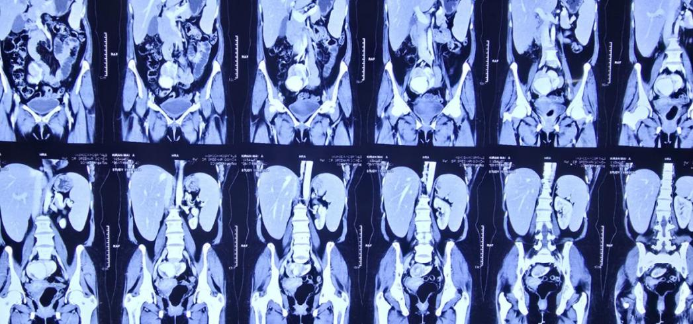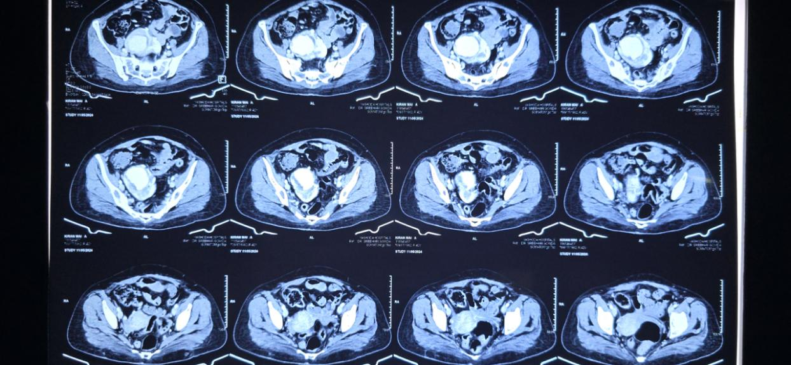

A

B

**Figure 1: Computed tomography of a coronal axis right kidney (A) and transverse axis (B), showing saccular aneurysm and hypo enhancing lesion in periphery the interpolar region of the kidney and vascular anatomy as described in the description.**

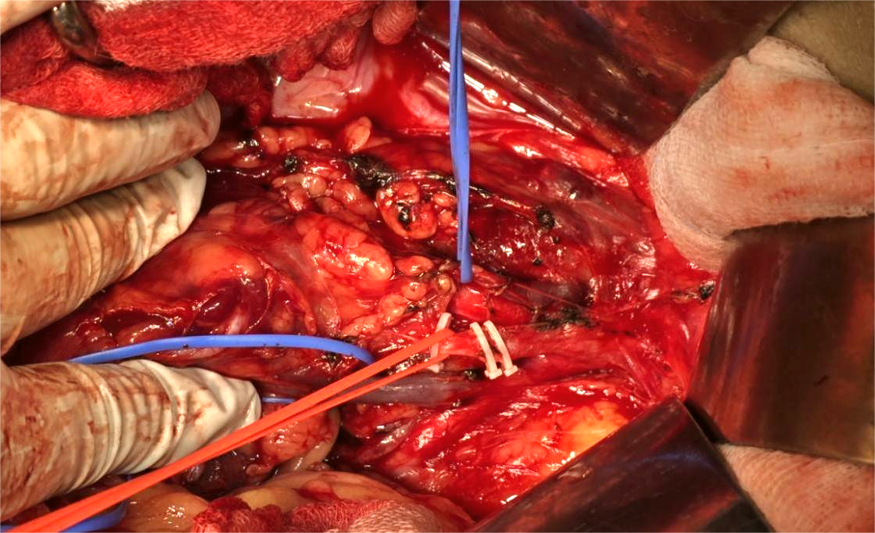

**Figure 2: Intraoperative picture showing two veins (blue colour loops) and renal artery (red loop) originating from aorta bifurcation.**

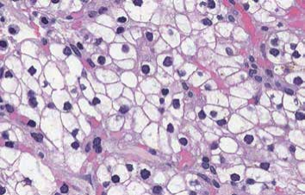

**Figure 3: Histopathology shows cells having clear cytoplasm and well defined cell membranes and are typically arranged in nests.**

After a multidisciplinary team discussion and the patient’s informed consent, the patient underwent radical right pelvic nephroureterectomy via transperitoneal approach. The postoperative period was unremarkable. Histopathologically specimen showed a unifocal tumor limited to the kidney measuring 4.5 x 3.2 x 2.5 cms with histological type as clear cell renal carcinoma and negative margins. TNM staging was pT1b N0 M0. Patient was doing well in postoperative period and on followup, there is no evidence of any local recurrence.

Discussion

Renal cell carcinoma (RCC) in ectopic kidneys, particularly pelvic kidneys, is an exceptionally rare clinical entity despite RCC being the most common renal malignancy. This rarity is highlighted by case reports and limited documented instances in medical literature, with only three cases referenced in Campbell-Walsh Urology.4 Renal ectopia is a rare condition where a mature kidney fails to migrate to its typical position within the renal fossa.

This congenital anomaly is found in 1 of 2100–3000 autopsies.5 Most pelvic kidneys are asymptomatic and there is not thought to be an increased susceptibility to disease.6 Congenital renal anomalies overall are identified in roughly 0.47% of autopsies, with common variants including pelvic ectopia, horseshoe kidneys and ectopic fused kidneys.7

Etopic kidneys are typically smaller in size and may not conform to the usual reniform (bean-like) shape due to developmental anomalies during embryogenesis. The renal pelvis is often positioned anterior to the renal parenchyma. The length of the ureter usually aligns with the position of the ectopic kidney, which rarely exhibits redundancy. In contrast, ptotic kidneys maintain their full ureteral length even after the kidney descends. Additionally, it is uncommon for the adrenal gland to be absent or abnormally positioned in cases of ectopic kidneys.8 In anatomical literature, there are two divergent opinions regarding the definitive position of the kidneys during development. The first viewpoint posits that the kidney ascends within the retroperitoneal space during early ontogenetic development. Initially, the renal rudiment forms in the pelvic region, specifically at the level of the L2 to L3 vertebrae. In this stage, the dorsal convex border and ventral hilum of the kidney are in contact with the abdominal wall.

To reach its final position, the kidney undergoes both ascension and rotation. This process typically occurs between the 6th and 9th weeks of gestation as the kidney moves upward along the dorsal aorta. Although the precise mechanism remains unclear, it is suggested that an inductive substance secreted by the developing kidney may be involved. Conversely, the second opinion argues that what appears to be kidney ascension is actually a pseudo ascension. This phenomenon is attributed to the rapid development of the caudal extremity of the fetus, which creates an illusion of movement as other structures grow more quickly than the kidneys themselves.9,10

The blood supply of an ectopic kidney is abnormal and depends on its final position. It typically receives one or two main renal arteries from the distal aorta or aortic bifurcation, along with additional arteries from the common, external or internal iliac arteries. Both the abdominal aorta and inferior vena cava (IVC) may adapt to these changes in blood flow.11 In most cases, the other kidney is normal, but sometimes it may be absent (contralateral agenesis). Bilateral ectopic kidneys are rare, occurring in about 10% of cases. Ectopic kidneys are often associated with other abnormalities, such as genital issues (especially in females), malposition of the colon and skeletal or gastrointestinal anomalies.12

Pelvic kidneys have a complex blood supply from nearby vessels, making surgery challenging due to unpredictable vascular anatomy. A detailed preoperative vascular assessment and careful surgical exploration are essential to avoid injury.13 Regular follow-up is important to detect new tumors, recurrence or metastases.

Conclusion

The management of renal cell carcinoma in ectopic kidneys requires careful surgical planning due to anatomical variations and potential complications associated with malrotation. This report aims to enhance awareness among clinicians regarding the potential for renal cell carcinoma to arise in ectopic and malrotated kidneys, highlighting the need for thorough imaging and consideration of anatomical anomalies in the diagnostic process. Early recognition and appropriate surgical intervention are crucial for improving patient outcomes in such rare presentation.

*Funding: No funding sources*

*Conflict of interest: None declared*

*Ethical approval: Not required*

References

1. Alokour RK, Ghawanmeh HM, Al-Ghazo M, Lafi TY. Renal cell carcinoma in ectopic-pelvic kidney: A rare case with review of literature. Turk J Urol. 2018;44(5):433-6.
2. Karaman N, Doğan L, Özaslan C, Atalay C, Irkkan Ç, Bozkurt A. Renal cell carcinoma in an ectopic kidney: case report. Acta Oncologica Turcica. 2009;42:74–6.
3. Safety and Efficacy of the Herbal Drug Hypericum Perforatum for the Treatment of Premature Ejaculation. Int J. 2012;5(3):22.
4. Fischer MA, Carlsson AM, Drachenberg DE, Gupta R, Norman RW. Renal cell carcinoma in a pelvic kidney. BJU Int. 1999;83:514.
5. Grotas AB, Phillips JL. Renal mass in solitary, crossed, ectopic pelvic kidney. Urology. 2009;73(6):1223–4.
6. Isabella D, Iain L, Richard K. Renal cell carcinoma in an ectopic pelvic kidney in a patient presenting with acute urinary retention. J Surg Case Rep. 2010;10:2.
7. Skandhan A, Amer M, Ashraf A. Ectopic kidney. Avaialble at: Radiopaedia.org. Accessed on 23 November 2024.
8. Karaman N, Doğan L, Özaslan C, Atalay C, Irkkan Ç, Bozkurt A. Renal cell carcinoma in an ectopic kidney: case report. Acta Oncologica Turcica. 2009;42:74–6.
9. Guidoni P. Embryologie, Editions Doin Deren et Cie Paris. 1968.
10. Moore KL. The developing human: clinically oriented embryology. Philadelphia: Saunders. 1982.
11. Dash I, Lyburn ID, Kinder R. Renal cell carcinoma in an ectopic pelvic kidney in a patient presenting with acute urinary retention. JSCR. 2010;10:2.
12. Mahmoudnejad N, Danesh A, Abdi H. Renal cell carcinoma in presacral pelvic kidney. J Pak Med Assoc. 2009;59:482–3.
13. Mahmoudnejad N, Danesh A, Abdi H. Renal cell carcinoma in presacral pelvic kidney. J Pak Med Assoc. 2009;59:482-3.

**Cite this article as:** Aregala P, Gowda S, Marda S, Jyoshna TM. Pelvic ectopic kidney with malrotation: a rare case report of renal cell carcinoma. Int Surg J 2025;12:865-7.